https://youtu.be/Zy1UjWQxm1M

https://github.com/EvanBrown-Git/Essentials
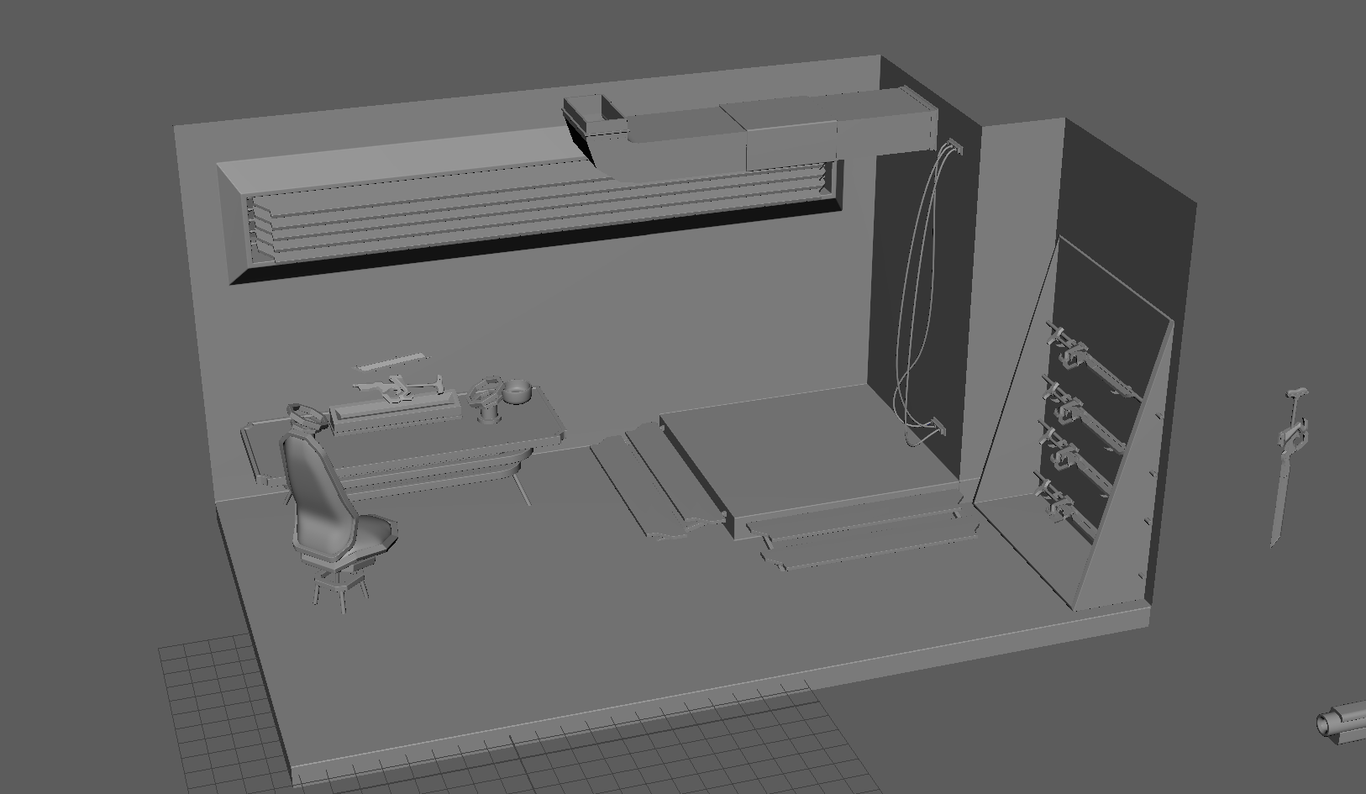
I added a vent in the corner of the room using cube primitives, extrude, bevel, edge loop, and bridge. I added cylinders to the shades on the window to add some realism (so they’re not just floating there). I added outlets to the wall using cubes with the extrude and bevel tools, and cylinders as the ports on the outlets. I used Bezier curves with sweepmesh to create wires to be plugged into the outlets. I took my original sword mesh and placed it on the table. I used cubes, cylinders, bridge, bevel, extrude, and edgeloop tools to create the futuristic workbench on the table. And I made a decorative bowl in the video linked above.
NOTE:
I like that I could change the shape of the wires with the original curves even after using sweepmesh.

